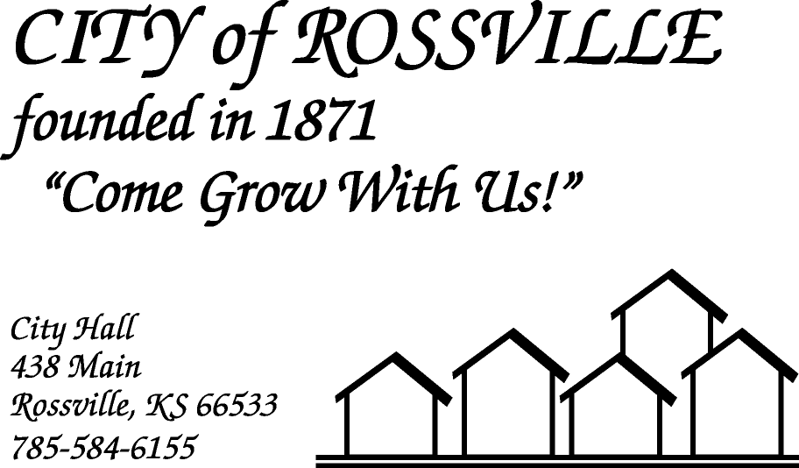

**AGENDA**

**MONDAY**

**OCTOBER 19, 2020**

***AGENDA SUBJECT TO CHANGE***

7:00 pm MINUTES

BILLS

ADOPT AGENDA

7:05 pm MORGAN HANSEN

Christmas Festival-2020

7:15 pm KELLY KENNEY

RHS Homecoming

7:25 pm BOB BROCK-KDOT

Capabilities Exercise & Demonstration

7:35 pm JON & SHERRY THEDERAHN

Property review by Code Enforcement

7:45 pm COUNCIL REPORT

7:50 pm UTILITY DEPT REPORT/BUSINESS

7:55 pm POLICE DEPT REPORT/BUSINESS

8:00 pm OLD BUSINESS

8:05 pm NEW BUSINESS

8:10 pm ADJOURN

**NOTE: The meeting will be online using ZOOM meeting service**

Meeting ID: 883 2437 7467   
Passcode: 547522

**Please call City Hall at 785 584-6155 if you need assistance.**